**Harnoor Rangi – InClass Assignment**

Question 1:

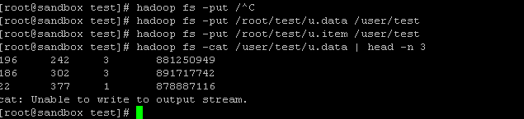

Question 2 :

Created tables

create table uitem (

movieid INT,

moviename string,

releasedate string)

row format delimited

fields terminated by '\t' ;

load data inpath '/user/test/u.item'

overwrite into table uitem;

create table udata

(userid INT,

movieid INT,

rating INT,

ts BIGINT)

row format delimited

fields terminated by '\t' ;

load data inpath '/user/test/u.data'

overwrite into table udata;

**Querry**

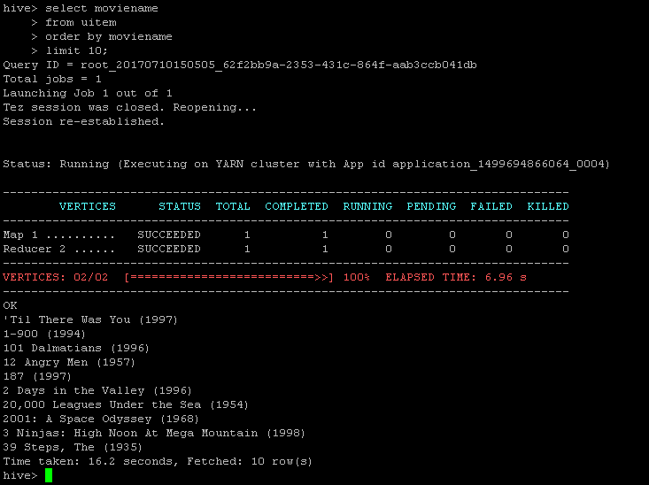

Question 3:

1)

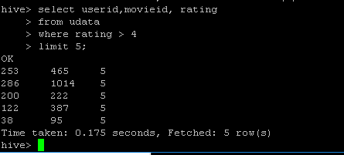

2)

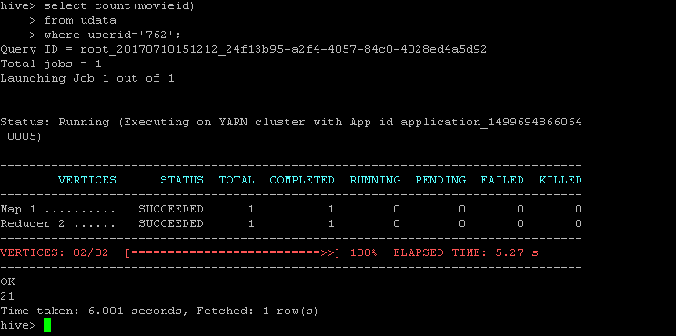

3)

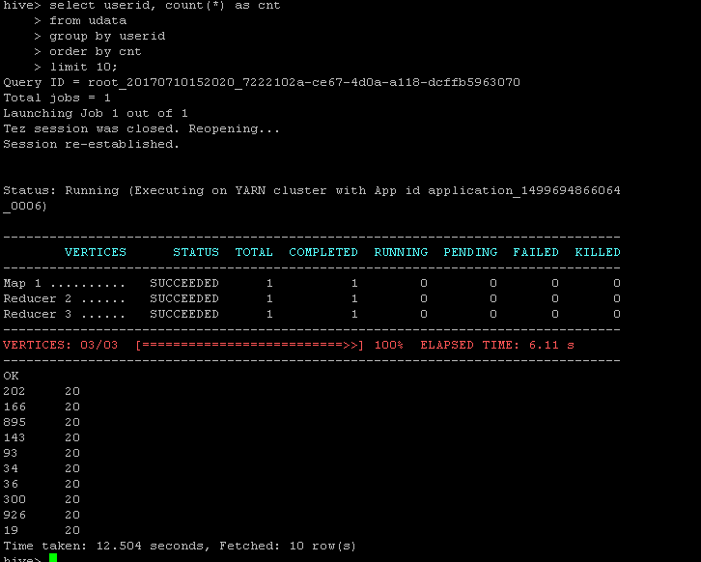

4)

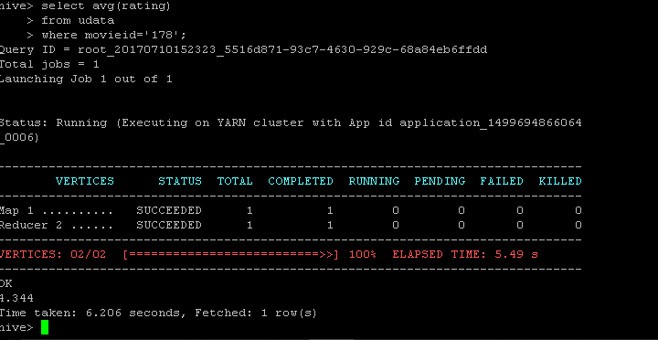

Question 4)

Use tables created by both u.item and u.data • Find all records with rating greater than 3 and output the movie name along rating for such records.

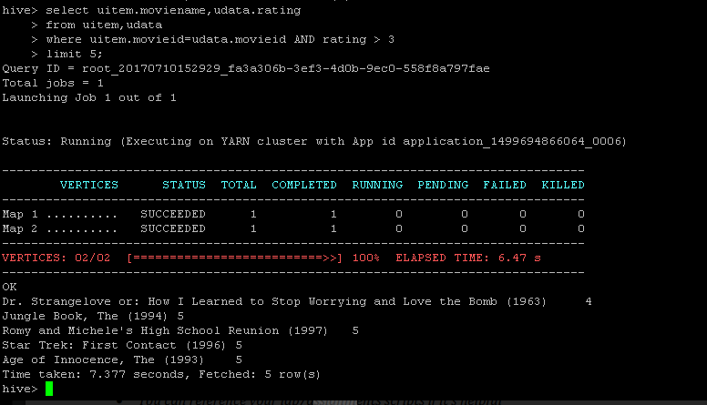

Question5)

